MSCS – 630 – B01

ADVANCED OPERATING SYSTEMS

SUMMER 2026

SECOND BI – TERM

PROJECT: ADVANCED SHELL SIMULATION WITH INTEGRATED OS CONCEPTS

DELIVERABLE 2: PROCESS SCHEDULING

BY

RESHMIKA GOTRU

STUDENT ID: 005033089

INSTRUCTOR: DR. SEAN PERRYMAN

INTRODUCTION
Deliverable 2 adds an internal CPU scheduling subsystem to the custom Unix-like shell created in Deliverable 1. The current architecture is maintained: builtin.cpp implements built-in commands and process, main.cpp launches the shell, shell.cpp manages command dispatch, and parser.cpp parses user input and background execution. Background jobs and actual external processes are managed by cpp. Simulated Process Control Blocks (PCBs), ready queues, timers, and configurable Preemptive Priority-Based scheduling, round robin scheduling, and performance measurements.
DELIVERABLE 1 INTEGRATION
Rather of being a stand-alone scheduler, the scheduling mechanism is an extension of the original MyShell application. The Deliverable 1 logic is still used by current commands like pwd, cd, echo, ls, mkdir, rmdir, rm, touch, cat, kill, jobs, fg, and bg. Fork(), execvp(), and waitpid() are still used by external commands. Deliverable 2 adds a scheduler-command dispatch section to shell along with scheduler.cpp and scheduler.h.CPP. The executable is still called shell.
PROCESS CONTROL BLOCK AND QUEUE MANAGEMENT
Each simulated process is represented by a PCB containing a scheduler PID, command name, arrival time, burst time, remaining time, priority, first-start time, completion time, insertion sequence, and state. Scheduler PIDs such as S1 and S2 distinguish simulated processes from the real operating-system PIDs used by Deliverable 1 background jobs. Processes transition among NEW, READY, RUNNING, and TERMINATED states.
Round-Robin uses a FIFO ready queue. Processes enter when their arrival time is reached, are removed from the front for execution, return to the tail when their quantum expires, and are removed from scheduling when complete. Priority scheduling uses a heap-based priority queue. Priority is the primary ordering key; arrival time and insertion sequence provide FCFS ordering for equal priorities.
ROUND – ROBIN SCHEDULING
Round-Robin assigns every ready process a configurable time quantum. The process at the front of the ready queue runs for the smaller of the quantum or its remaining burst. If it completes, completion time is recorded and the process becomes TERMINATED. Otherwise, it returns to the tail of the ready queue. New arrivals are admitted as simulated time advances without interrupting the current quantum.
Demonstration:
schedule rr 2 250
add 5 2 0 task-A
add 3 1 0 task-B
add 4 3 1 task-C
schedjobs
run
metrics
This workload demonstrates quantum configuration, process switching, queue-tail rotation, completion/removal, and metrics. Running the same test with another quantum, such as S3, demonstrates that the time slice is configurable rather than hard-coded.
PRIORITY – BASED SCHEDULING
Priority-Based scheduling is preemptive. Smaller numeric values represent higher priorities. Execution advances one simulated CPU unit at a time. After each unit, newly arrived processes are admitted. If the highest-priority ready process has a higher priority than the running process, the running process is preempted and returned to READY while the higher-priority process is dispatched. Equal-priority processes are ordered by arrival time and insertion sequence, implementing FCFS tie-breaking.
Demonstration:
schedule priority 250
add 6 3 0 low-priority-task
add 4 2 1 medium-priority-task
add 2 1 2 high-priority-task
add 3 2 2 equal-priority-task
schedjobs
run
metrics
At t=0, S1 begins with priority 3. At t=1, S2 arrives with priority 2 and preempts S1. At t=2, S3 arrives with priority 1 and preempts S2. The priority-2 jobs are then handled using FCFS ordering.
TIMER SIMULATION
The scheduler uses std::this_thread::sleep_for() and std::chrono::milliseconds to simulate CPU execution. The optional delay_ms controls demonstration speed. A value such as 250 makes switching visible in real time, while 0 performs the same logical simulation immediately for testing.
PERFORMANCE METRICS
The required metrics are calculated as follows:
Turnaround Time = Completion Time - Arrival Time
Waiting Time = Turnaround Time - Burst Time
Response Time = First Start Time - Arrival Time
For the demonstrated Round-Robin workload with quantum 2, the average waiting time is 6.33, average turnaround time is 10.33, and average response time is 1.67.
For the demonstrated preemptive Priority workload, the average waiting time is 4.00, average turnaround time is 7.75, and average response time is 1.25.
For these specific workloads, Priority scheduling gives lower averages because higher-priority work can preempt lower-priority work. Round-Robin, however, provides stronger fairness. Fixed Priority scheduling can starve lower-priority processes if higher-priority work continually arrives.
SCREENSHOTS
The following screenshots are the actual execution evidence captured from MyShell and are presented in execution order.

Figure 1. Successful build, shell launch, Round-Robin configuration, and process creation.
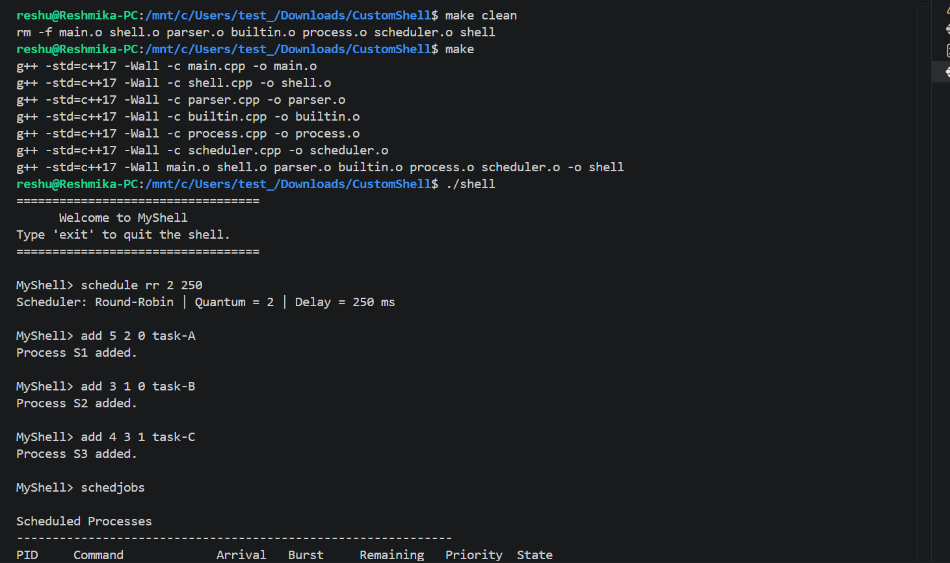

The shell compiles successfully. Round-Robin is configured with quantum 2 and 250 ms delay, and S1–S3 are added.
Figure 2. Round-Robin queue management and process switching.
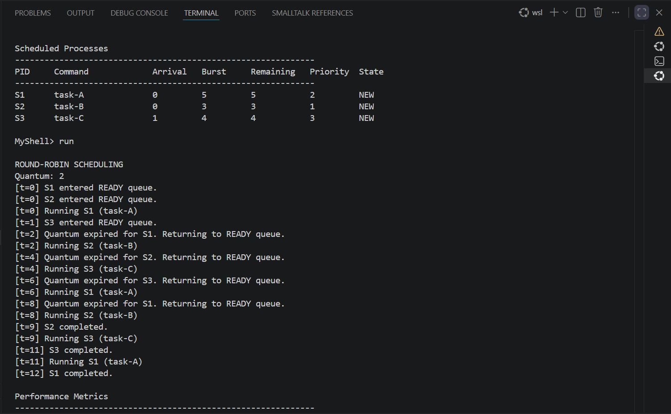
The trace shows READY-queue admission, FIFO execution, quantum expiration, re-queuing, and process completion.
Figure 3. Round-Robin performance metrics.

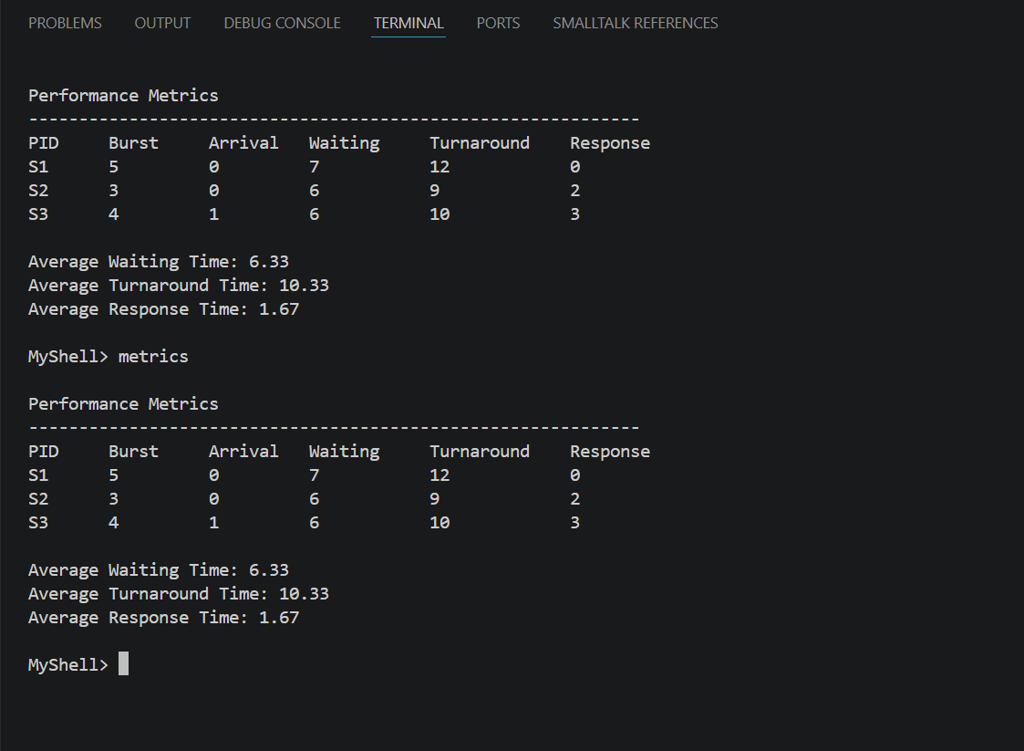
The measured averages are waiting time 6.33, turnaround time 10.33, and response time 1.67.
Figure 4. Preemptive Priority configuration and process queue.

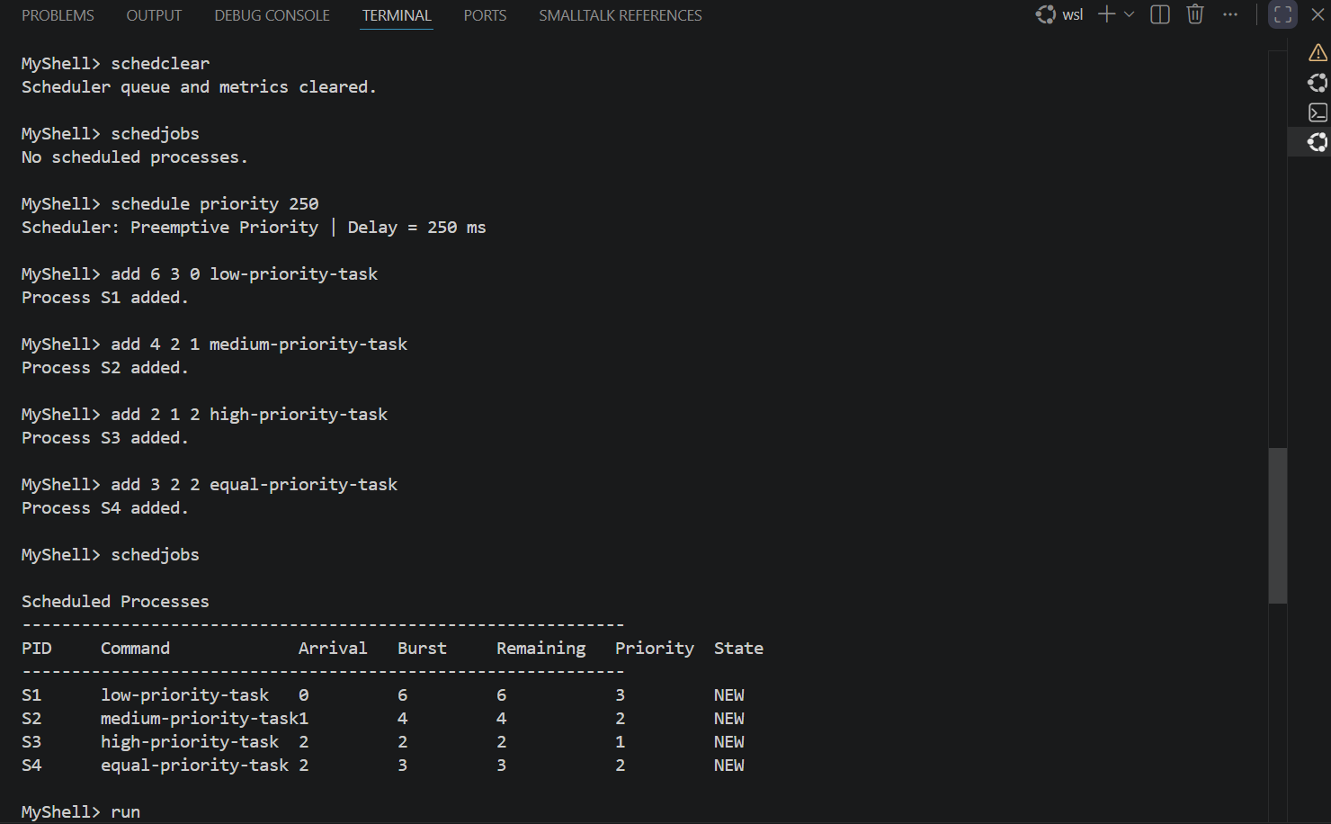
Scheduler data is cleared, Priority scheduling is selected, and four processes with arrival times and priorities are added.
Figure 5. Priority preemption, FCFS tie handling, and performance metrics.
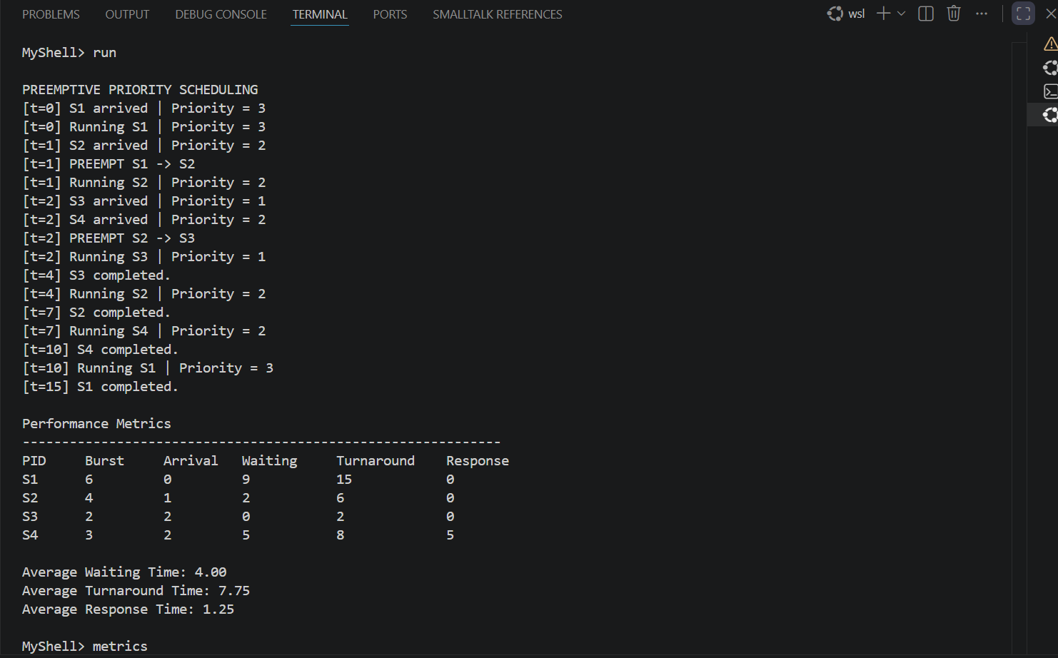
S2 preempts S1 at t=1 and S3 preempts S2 at t=2. S2 executes before equal-priority S4, demonstrating FCFS tie handling. Averages are 4.00, 7.75, and 1.25.
Figure 6. Priority metrics verification.
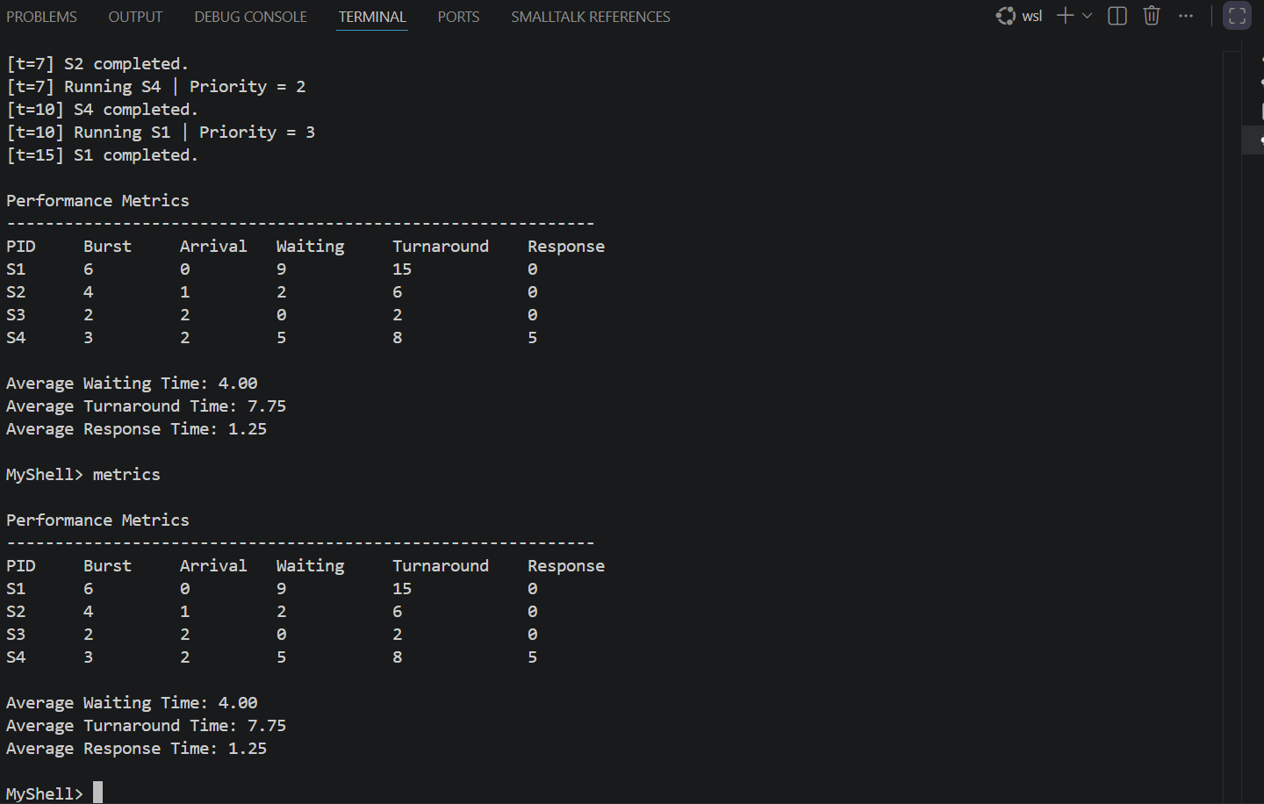
The metrics command reproduces the completed Priority scheduling statistics.
Figure 7. Round-Robin with configurable quantum 3.
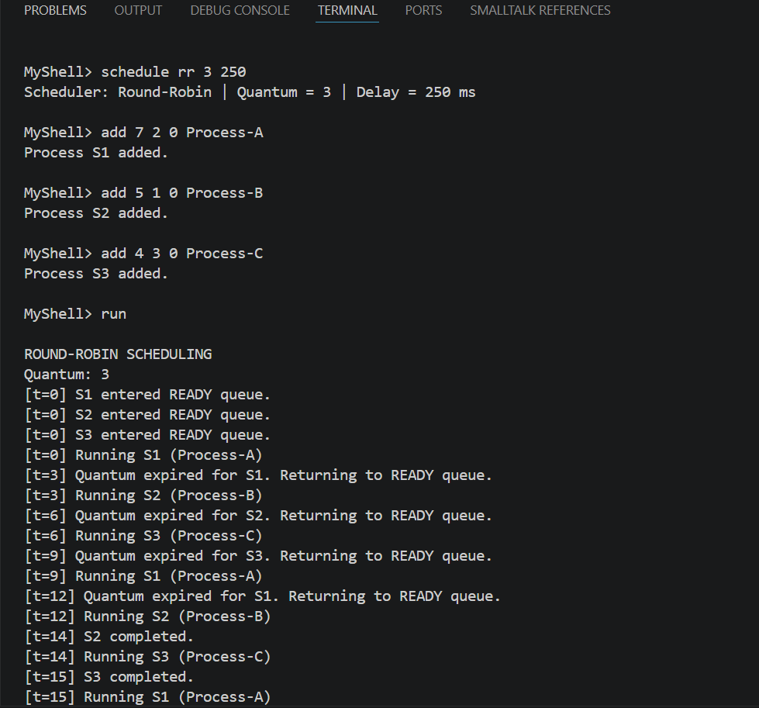
A second Round-Robin run uses quantum 3, demonstrating that the time slice is configurable rather than hard-coded.
Figure 8. Performance metrics for the quantum-3 Round-Robin workload.
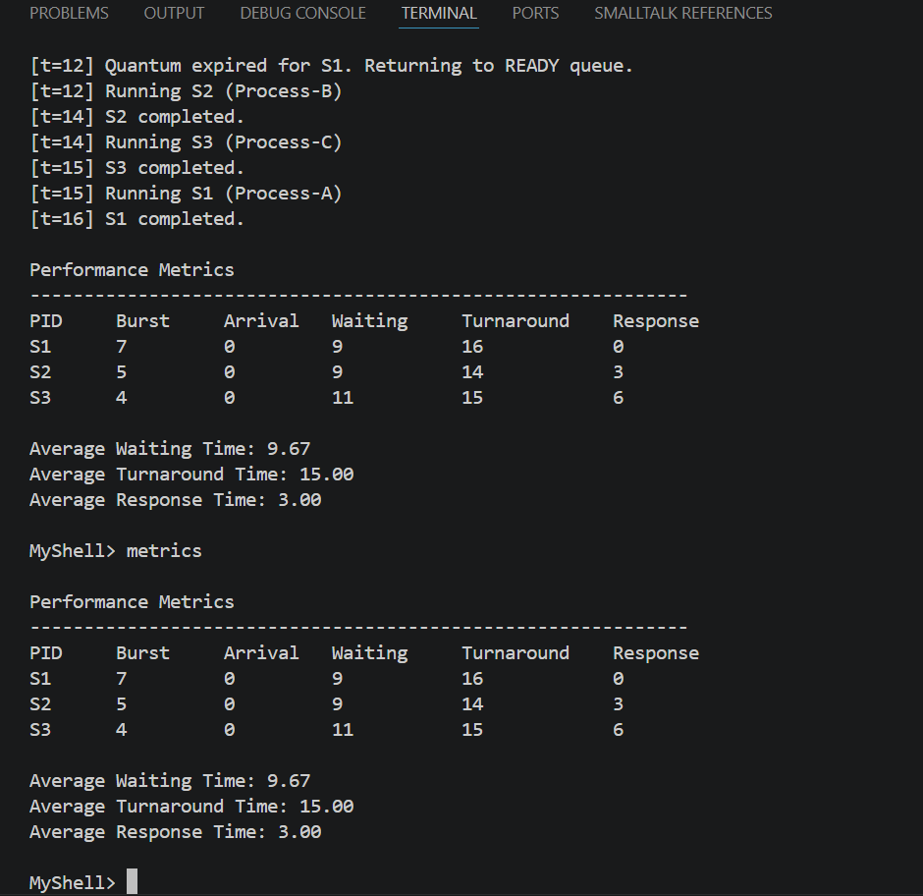
This workload reports averages of 9.67 waiting, 15.00 turnaround, and 3.00 response time.
Figure 9. Input validation and error handling.
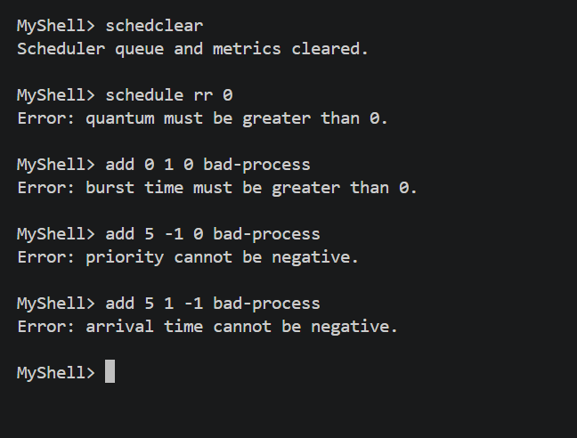
Invalid quantum, burst time, priority, and arrival values are rejected with readable errors without terminating the shell.
Figure 10. Deliverable 1 and Deliverable 2 integration.
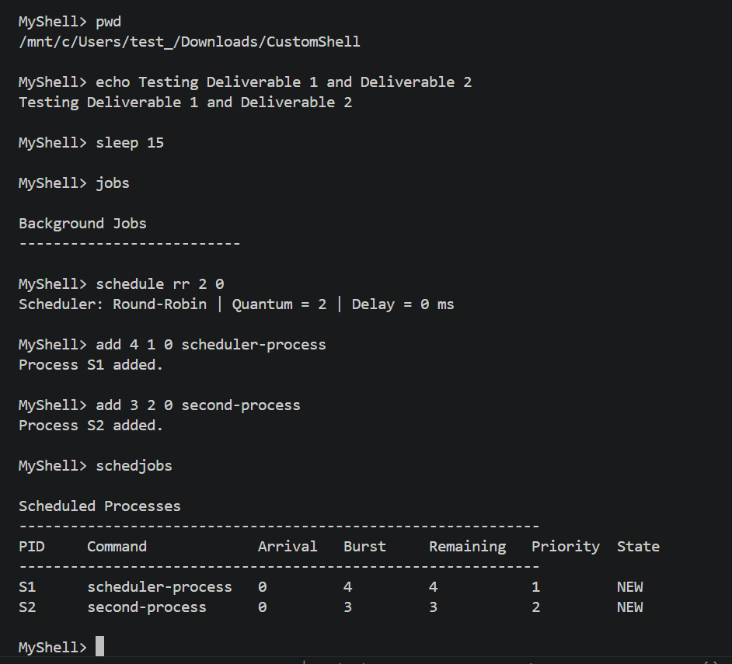
Original commands such as pwd and echo execute in the same MyShell session as the new scheduler commands, demonstrating integration rather than a standalone replacement.
CHALLENGES AND SOLUTIONS
Integration with Deliverable 1: The scheduler had to be added without replacing the existing shell. This was solved by preserving the original modules and adding scheduler.cpp/scheduler.h as a separate component invoked through the existing command loop.
Queue Management: Round-Robin requires FIFO rotation while also admitting newly arrived processes. The implementation tracks admission and returns unfinished processes to the queue tail.
Priority Preemption: A higher-priority arrival must interrupt lower-priority work. Priority execution therefore advances one CPU unit at a time and checks the heap for a higher-priority ready process.
FCFS Ties: Equal – priority processes require deterministic ordering. Arrival time and an insertion sequence are included in the comparator.
Metric Accuracy: First-start time is recorded only once and completion time only when remaining time reaches zero.
Input Validation: Invalid quantum, negative delay, zero burst, negative priority, negative arrival time, and invalid job identifiers are rejected with readable errors rather than terminating the shell.
FUTURE IMPROVEMENTS
Future improvements could include priority aging to prevent starvation, context-switch counters, a Gantt-chart display, loading process definitions from files, automated tests, and scheduling real child processes with SIGSTOP/SIGCONT rather than simulated CPU bursts.
BUILD AND EXECUTION
Compile and run the integrated shell with:
make clean
make
./shell
The updated Makefile compiles main.cpp, shell.cpp, parser.cpp, builtin.cpp, process.cpp, and scheduler.cpp into the same shell executable.
CONCLUSION
Deliverable 2 successfully extends MyShell with internal process scheduling while preserving the Deliverable 1 shell architecture and process-management features. The implementation supports configurable Round-Robin scheduling, heap-based preemptive Priority scheduling, FCFS tie-breaking, timer-based execution simulation, ready-queue management, process-state tracking, and waiting, turnaround, and response-time metrics. These features directly address the required Deliverable 2 functionality and rubric criteria.
REFERENCES
- Silberschatz, A., Galvin, P. B., & Gagne, G. (2018). Operating System Concepts (10th ed.). Wiley.
- Stallings, W. (2018). Operating Systems: Internals and design principles (9th ed.). Pearson.
- Tanenbaum, A. S., & Bos, H. (2015). Modern Operating Systems (4th ed.). Pearson.

